**Hello World RESTful Web Service**

Write a REST service in the spring learn application created earlier, that returns the text "Hello World!!" using Spring Web Framework.

**HelloController.java**

package com.cognizant.spring_learn.controller;

import org.slf4j.Logger;

import org.slf4j.LoggerFactory;

import org.springframework.web.bind.annotation.GetMapping;

import org.springframework.web.bind.annotation.RestController;

@RestController

public class HelloController {

private static final Logger LOGGER = LoggerFactory.getLogger(HelloController.class);

@GetMapping("/hello")

public String sayHello() {

LOGGER.info("START - sayHello()");

String message = "Hello World!!";

LOGGER.info("END - sayHello()");

return message;

}

}

**application.properties**

server.port=8083

logging.level.com.cognizant.spring_learn=DEBUG

**Output**

**> ./mvnw spring-boot:run**

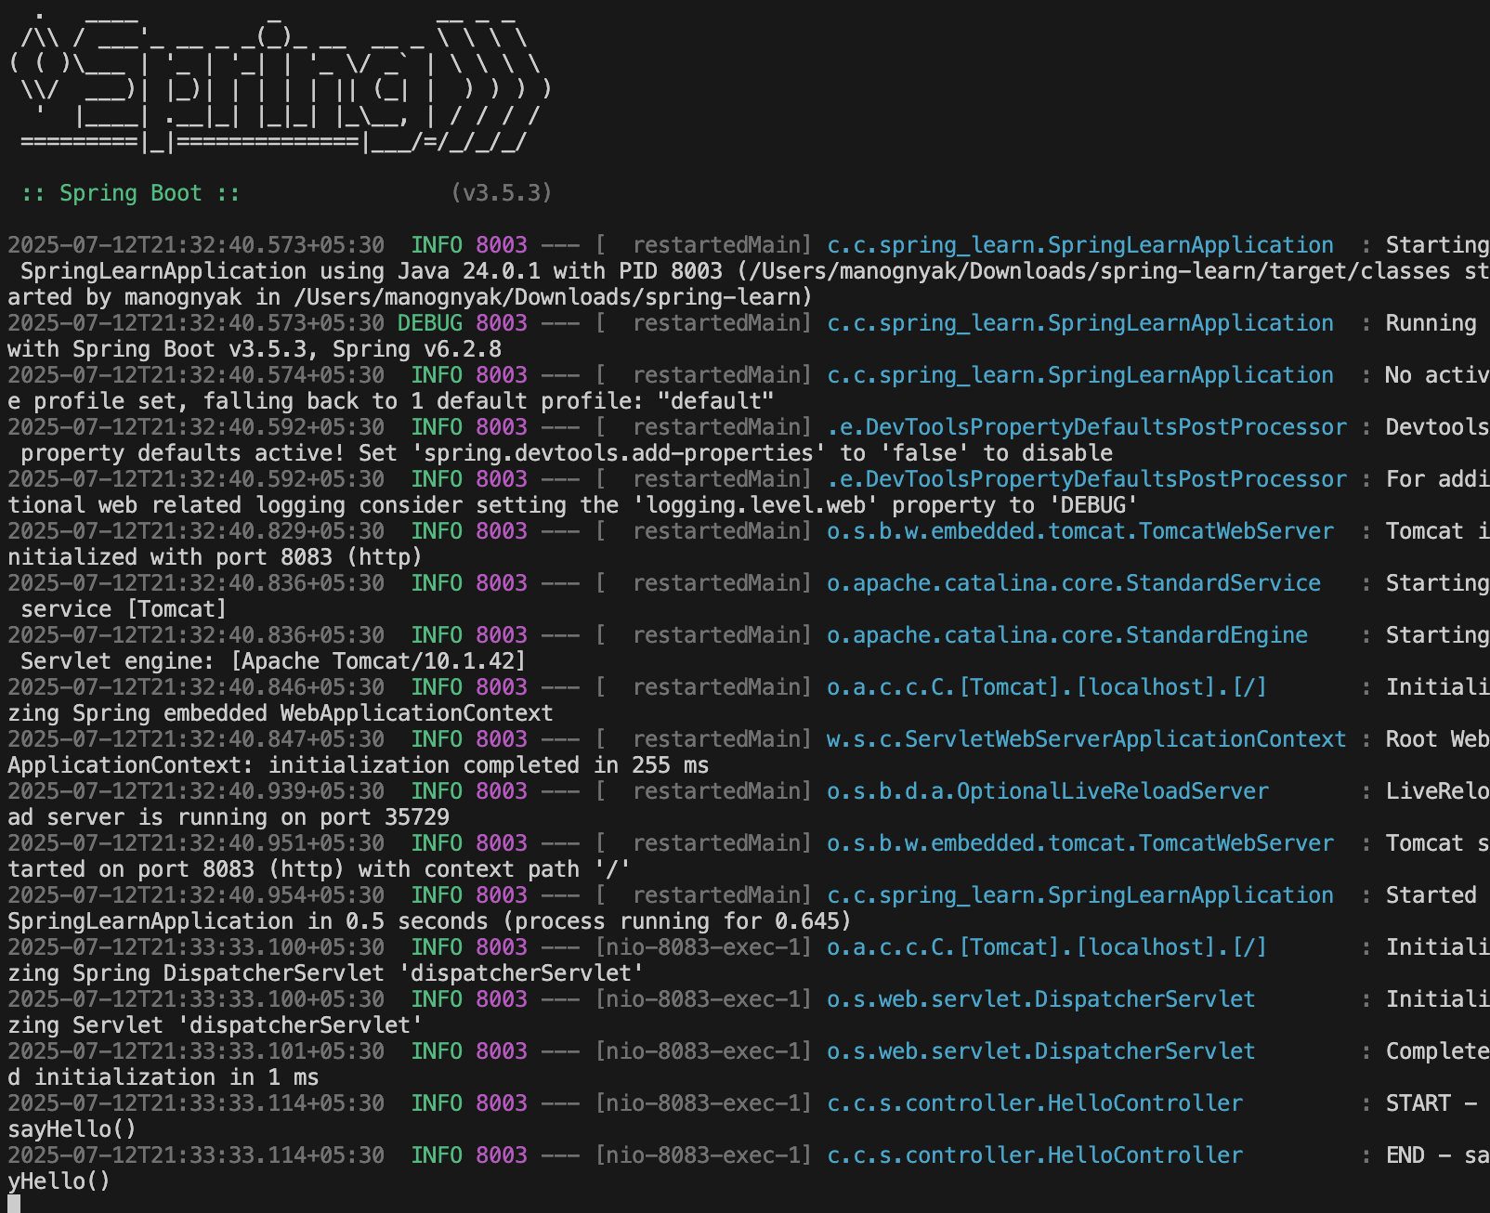

**>**[**http://localhost:8083/hello**](http://localhost:8083/hello)

**SME**

* **In network tab of developer tools show the HTTP header details received**

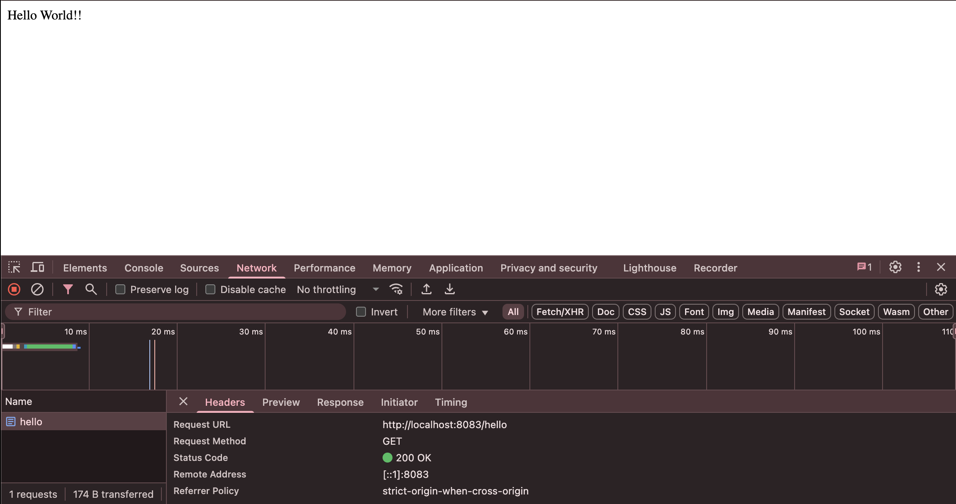

* **In postman click on “Headers” tab to view the HTTP header details received.**

